**LEBANESE AMERICAN UNIVERSITY**

**USAID – HIGHER EDUCATION SCHOLARSHIP PROGRAM**

**HES - Volunteering Program Verification Form**

This form is to be used to document volunteering hours. If a student volunteers for multiple organizations, a separate form must be used for each organization. **This form must be turned in by the 28th of each month, the latest.**

I certify that the scholar Mayan Al Ashy completed a total of 5 hours of service at InnovaThrive.

The hours were completed hours as per the below:

Hours # 2 (date) _2/12 – 6/12_ (initials of supervisor) __A.K.___

Hours # 2 (date) _9/12 – 13/12_ (initials of supervisor) __A.K.___

Hours # 1 date) _16/12 – 20/12 (initials of supervisor) __A.K.___

Hours # 0 date) _23/12 - 27/12 (initials of supervisor) __A.K.___

Brief description of the activities the scholar performed or participated in:

Blockchain in Digital Voting for Corporate Decision-Making  
Definition: Investigating blockchain’s potential to improve shareholder voting transparency.  
Technologies:  
  
  
Blockchain for immutable vote records.  
  
Smart contracts for vote automation.  
  
Applications:  
  
Ensuring transparency in corporate elections.  
  
Reducing manipulation in proxy voting.  
  
Statistics: Case studies show blockchain adoption reduces vote tampering by 50%.  
  
Advantages:  
  
Enhanced trust in corporate governance.  
  
Streamlined processes for large organizations.  
  
Disadvantages:  
  
High costs for initial implementation.  
  
Challenges:  
  
Achieving consensus on global standards for corporate blockchain voting.  
  
Future Research:  
  
Integration with AI for vote trend analysis.  
  
  
Expanding blockchain voting to smaller enterprises.

Written feedback about the scholar’s performance:

Mayan’s research on blockchain for digital voting in corporate decision-making emphasized its ability to ensure transparency and reduce manipulation. The potential for integrating AI for vote analysis adds an innovative angle to future research.

Please rate the overall performance of the scholar at your organization:

|  |  |  |  |
| --- | --- | --- | --- |
|  | Mastery (5) | Proficient (3) | Emerging (1) |
| **Problem solver** | X |  |  |
| **Engaged & Committed** | X |  |  |
| **Open-minded & multicultural** | X |  |  |

Signature

& stamp

__________________________

_

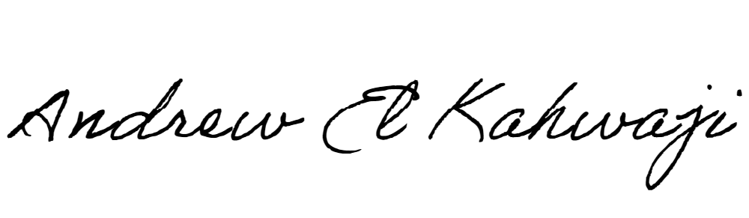

Printed Name _Andrew El Kahwaji_

Date __26/12/2024___

Email __andrew.lifesculptor.coo@gmail.com __

Phone __+961 71 914 378__